**Problem-2**

**Student Name: Milan Sharma UID: 23MAI10003**

**Branch: ME – CSE - AIML Section/Group: MAI– 1 (A)**

**Semester: 1st Date of Performance:**

**Subject Name: Python Programming Subject Code: 23 CSH 623**

1. **Aim of the Experiment :**

Pooja would like to withdraw X $US from an ATM. The cash machine will only accept the transaction if X is a multiple of 5, and Pooja's account balance has enough cash to perform the withdrawal transaction (including bank charges).

For each successful withdrawal the bank charges 0.50 $US.

Calculate Pooja's account balance after an attempted transaction.

1. **Objective of the Experiment :**

Objective of the Experiment is that we have to calculate the output of the account balance after the attempted transaction, given as a number with two digits of precision. If there is not enough money in the account to complete the transaction, output the current bank balance.

1. **Algorithm/ Steps for Experiment :**

Step 1:Takes two integer inputs from userone is the amount of cash which Pooja wishes to withdraw and another is Pooja's initial account balance.

Step 2:The map() function takes a function (in this case, the float function).

Step 3: The map() function applies it to each part of the enumerable returned by the split() function.

Step 4: variable n is assigned the value of the expression int(n).

Step 5: Check if condition for withdraw amount+0.5<=initial balance and withdraw amount %5==0

Step 6: If the condition is true print the initial amount – withdrawal amount – 0.5.

Step 7: If the condition is false print the initial amount.

1. **Code for Experiment :**

n,atm=map(float,input().split())

n=int(n)

if (n+0.5<=atm and n%5==0):

print(float(atm-n-0.5))

else:

print(float(atm))

1. **Result/Output :**

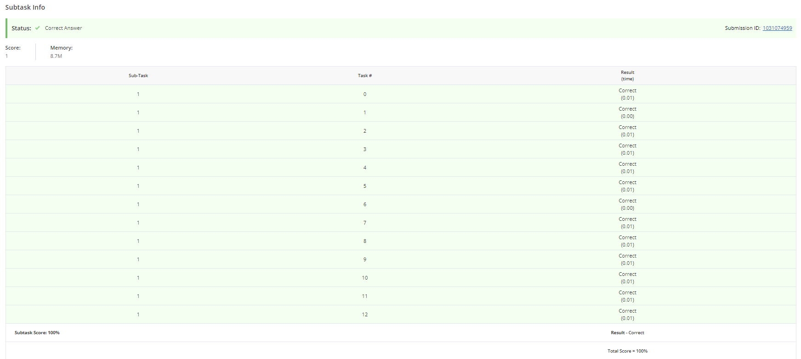

**Learning outcomes (What I have learnt):**

1. Learnt about the python programming.
2. Learnt how to take input from the user in integer.
3. Learnt about if else condition in python.
4. Learnt about map() function.
5. Learnt about split() function.